|  |  |
| --- | --- |
| DC DISCHARGE pLASMA  Modelling breakdown voltages using a Paschen curve | Abstract  In this lab, you will synthesize the third and arguably most intriguing state of matter artificially using a high voltage source, a pump, pressure gauges and a vacuum tube. You will take multiple data readings from your setup and once we have a complete plot, we will superimpose a Paschen model and see how well the data coincides with the theoretical prediction. Along with routine data analysis and measures of central tendency, we will gauge some sort of measure of fitness to quantitatively determine how well the data coincides with the theoretical model.  Leoul Mesfin Gezu  Phys-368: Advanced Lab II |

Introduction 1

# Introduction

# Pre-lab Preparation

What is Plasma?

You are undoubtedly familiar with the commonly known “three states of matter”. Considering that 99% of the visible universe is actually made up of the lesser known fourth state of matter, you’d think it would be a little more widely recognized. If you’ve taken enough physics/general science, you are probably familiar with the term plasma. Answering the question “what is plasma?” actually continues the story of matter so far quite nicely. We know solids are rigid in shape and fixed in volume because their atoms are held together tightly. Liquids are held together a little less forcefully and so generally have free-formed shape, although they aren’t free enough to have unfixed volume as well. Forces between gases are so negligible that we usually assume the only interactions between them are kinetic[1] (atoms colliding). They have free-forming shape and volume that usually depends on their container (whether that’s your standard gas cylinder or the entire atmosphere). Now, imagine taking a gas and giving its atoms so much energy that the electrons that are bound to its nucleus have enough excitation to escape the electromagnetic force that had bound them to the nucleus. Pop off enough of them from their orbit and you can imagine a cloud of electrons occupying space the same way gas atoms do. That soup of negatively charged electrons and positively charged gas ions, that is plasma.

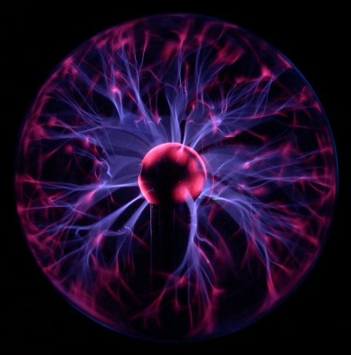

Fig. : Plasma Lamp[2]

Imagine its movie night and you have your favorite flavor of microwave popcorn ready to be completely finished only five minutes in. Before you put the pouch in the microwave, all you have are the hard, little corn kernels. Once they start heating up in the oven, the kernels “pop” and, eventually, you have a bag of popcorn. I think this is a solid metaphor for plasma formation. Remember, heat is a form of energy. Just like our corn kernels, transferring enough energy to our gas atoms makes their electrons “pop” off their orbits, ionizing the atom and forming the cloud we refer to as plasma.

Now, how do you know your popcorn is done? Well, the directions probably tell you how long to keep it in the microwave. Imagine we didn’t have that convenience. Imagine being inside that bag as those kernels pop (specifically the top of the bag). The first one goes off and a delicious singular popcorn flies to the top of the bag straight at you. Then, another one. The more energy is transferred to the kernels, the more popcorn flies to the top. The same way more kernels pop as it gets hotter, the more electrons pop as energy is transferred to the gas. Bringing the metaphor together, once about 90% of your kernels have popped, your popcorn is ready. Once about 90% of the atoms in a gas have ionized, we say it is fully ionized plasma.

Studying plasma

*Talking about popcorn is all well and fun but, unfortunately, plasma is considerably more complicated than popcorn and this is about where our metaphor stops tracking. This lab is much more rewarding if you gain an appreciation for what plasma really is. And so, if you feel like you need a little bit more background on plasma and its properties, I urge you to stop and watch this great video*[3] *and any other resources you can find before we build more complexity into our understanding.*

If we as physicists are to study plasma formation, we have two choices. We can wait for nature to create them (as it does all the time in the form of lightning strikes and solar winds). That would be very inconvenient, unpredictable and mildly dangerous. Thankfully, we have methods for artificially forming plasma in the lab, the most inexpensive and methodically straight-forward of which is the use of parallel plates and a high voltage source. Remember, all we need to do is somehow transfer enough energy to the gas atoms that their electrons ionize and we form plasma. If we keep this plasma somehow enclosed, we can observe its formation and even keep track of certain important numbers (the pressure in the tube, the distance between the plates and the voltage we needed to hit to see our first formation of plasma).

Part of being a physicist is understanding that you do not need to rediscover the electron in order to execute a successful experiment. In reality, the relationships between those numbers I just mentioned are very well documented, confirmed and understood. This very same lab has been repeated by thousands of students across multiple academic institutions across multiple continents. By no means should this be discouraging. Peer review is the bread and butter of the research. The fact that you can repeat this lab, executing it the same way it has been done in previous iterations and potentially get comparable results is the very fabric of the scientific method. In the future, you may perform an original experiment of your own that gets peer-reviewed by thousands of scholars to come. But, for now, let’s learn what our predecessors have found and form a hypothesis to test for ourselves.

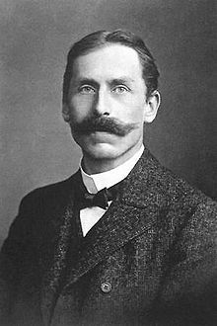Paschen’s Law

The German physicist with the phenomenal mustache you see to the right was Friedrich Paschen. One of his most important contributions to the world of physics was the relationship between the voltage that is necessary to start a discharges/electric arc between two electrodes as a function of surrounding pressure and the gap length between the electrodes. An electric arc is indeed plasma, so we’re talking about plasma formation here. This relationship is now dubbed Paschen’s Law and is the cornerstone of this entire lab activity. Before Paschen’s Law empirically states it for us, let’s conceptually think about what the relationships between breakdown voltage, pressure and separation distance could be.

Imagine we had a constant separation distance (we’re changing just the pressure and seeing how the breakdown voltage is affected). Thinking about how pressure affects a gas, more pressure bearing down on our gas atoms would likely mean it is harder for the anything (atoms or electrons or corn kernels) to move freely and ionize. Therefore, we would expect more energy to be required and therefore a higher breakdown voltage necessary as pressure increases.

Fig. 2: Friedrich Paschen

Now, we also know that the voltage between two electrodes is directly proportional to the distance between them[4]. Imagining that the pressure was constant and we’re just changing the separation distance, we would expect that a shorter distance between the electrodes would require less voltage.

Despite these reasonable expectations, real-life measurements find that while the voltage necessary decreased as pressure was decreased, it eventually increases gradually and even exceeds the original value. Similarly, the voltage necessary decreased as the separation distance decreased, but only to a certain point. It also then exceeds its original value. This is indeed very surprising, and was the dilemma that Paschen and colleagues set out to sort. Paschen experimentally discovered the relationship between these three values and it is empirically stated in Paschen’s Law:

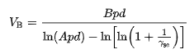

Fig. 3: Paschen’s Law[5]

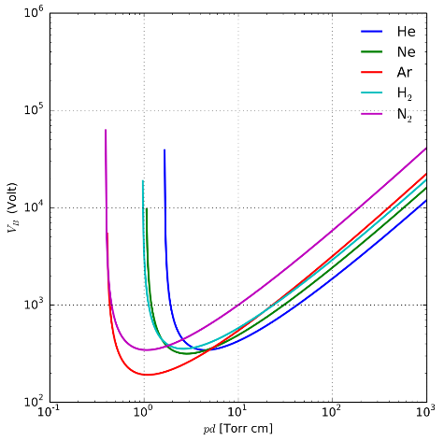In this equation, Vb stands for breakdown voltage and pd stands for pressure times distance (not potential difference!). This is key. Plotting Paschen’s Law leads to a Paschen curve with breakdown voltage on the dependent axis and the product of pressure and separation distance on the independent axis. This is unusual if you are used to seeing only one variable on a single axis, but don’t worry. Everything you know about axes still applies; you just have this new pressure-distance variable on your x-axis and breakdown voltage on your y-axis. The rest of the quantities in this equation are A and B, which are experimentally found constants that are usually in a certain range for a given gas, and the γ, which is also a constant known as the secondary electron emission coefficient. It is also given for a certain gas.

Figure 4: Paschen curves for different gases

And with that, you have all the background knowledge you need to execute and more importantly enjoy this lab. This is the step in the process where you look back and make sure all the concepts from the definition of plasma to the unusual x-axis in our Paschen curve make sense. Don’t be afraid to look back and/or consult other resources if anything feels too daunting. Proceed to the next section when you are ready!

1. See Kinetic Theory of Gases if you would like to learn more about how we treat gases for thermodynamic considerations: https://en.wikipedia.org/wiki/Kinetic_theory_of_gases
2. https://en.wikipedia.org/wiki/File:Plasma-lamp_2.jpg
3. https://www.youtube.com/watch?v=zqzWfguYj1c
4. See “parallel plate voltage” or the following resource if you need a little revision on this: https://flexbooks.ck12.org/cbook/ck-12-physics-flexbook-2.0/section/16.1/primary/lesson/the-electric-potential-in-a-uniform-field-phys
5. https://en.wikipedia.org/wiki/Paschen%27s_law